1. **Data Science Task Categories**:
   * **Data Management**: This involves collecting**, storing, and retrieving data** securely and efficiently from various sources such as social media, e-commerce platforms, sensors, etc.
   * **Data Integration and Transformation**: Known as ETL (Extract, Transform, Load), this process deals with **extracting** data from multiple sources**, transforming it into a suitable format,** and loading it into a central repository like a Data Warehouse.
   * **Data Visualization**: It refers to representing data and information graphically using **charts, plots, maps, animations, etc**., making it easier for decision-makers to understand and analyze.
   * **Model Building**: This step involves training data using machine learning algorithms to analyze patterns and build predictive models.
   * **Model Deployment**: It involves integrating the developed models into production environments, making them accessible via APIs for use by business applications and decision-makers.
   * **Model Monitoring and Assessment**: Continuous monitoring to ensure model accuracy, fairness, and robustness, using tools like Fiddler and evaluation metrics such as the F1 score.
2. **Tools and Processes**:
   * **Data Asset Management**: Involves organizing and managing data collected from different sources using platforms that support versioning, collaboration, replication, backup, and access right management.
   * **Code Asset Management**: Refers to version control and collaboration for managing code files, ensuring that changes can be tracked, managed, and synchronized among team members.
   * **Development Environments (IDEs)**: Provide a workspace and tools for developers to write, test, and deploy code efficiently, often including features like testing and simulation tools.
   * **Execution Environments**: Provide libraries to compile source code and system resources to execute and verify the code, often available in cloud-based environments that offer flexibility and scalability.
   * **Fully Integrated Visual Tools**: Comprehensive tools that cover all aspects of the data science workflow, including development, visualization, model building, deployment, and monitoring.
3. **Processes and Steps**:
   * **Data Management**: Involves collecting data from various sources, persisting it securely, and ensuring it is available for analysis when needed.
   * **Data Integration and Transformation (ETL)**: Extracts data from multiple sources, transforms it into a suitable format, and loads it into a central repository for analysis.
   * **Data Visualization**: Transforms data into visual representations such as charts and graphs to aid in understanding and decision-making.
   * **Model Building**: Involves training data using machine learning algorithms to develop predictive models based on patterns in the data.
   * **Model Deployment**: Integrating developed models into production environments, making them accessible via APIs for use in business applications.
   * **Model Monitoring and Assessment**: Continuously monitoring model performance to ensure accuracy, fairness, and robustness, using tools and evaluation metrics.
4. **Examples of Tools**:
   * **IBM Watson Machine Learning**: Provides tools and services for building and deploying machine learning models.
   * **SPSS Collaboration and Deployment Services**: Used for deploying assets created by SPSS software tools suite.
   * **Fiddler**: A tool used for monitoring the performance of deployed models in a production environment.
   * **IBM Watson OpenScale**: Continuously monitors deployed machine learning and deep learning models to improve accuracy and quality.
   * **GitHub**: A web-based platform for code hosting, version control, and collaboration among developers.
   * **IBM Watson Studio**: An integrated environment for data scientists to build, train, and deploy AI models.
   * **IBM Cognos Dashboard Embedded**: A tool for developing dashboards to visualize and analyze data.
5. **Open-Source Data Management Tools**:
   * **Relational Databases**: These include widely-used systems such as **MySQL(**. common use is for web applications, data warehousing, and e-commerce) and **PostgreSQL(support for JSON, full-text search, and spatial(occupying more space) data)**.which are structured data storage solutions
   * **NoSQL Databases**: Examples like **MongoDB**

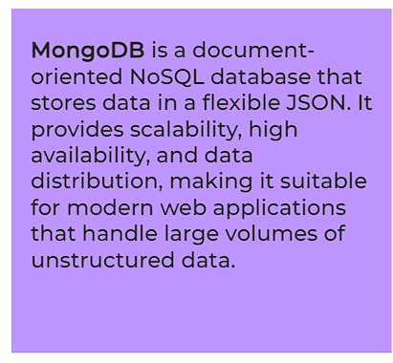

**Apache CouchDB(NoSQL document-oriented database that uses JSON to store data.(highly scalable, fault-tolerant, and easy to use.** and **Apache Cassandra**

* + 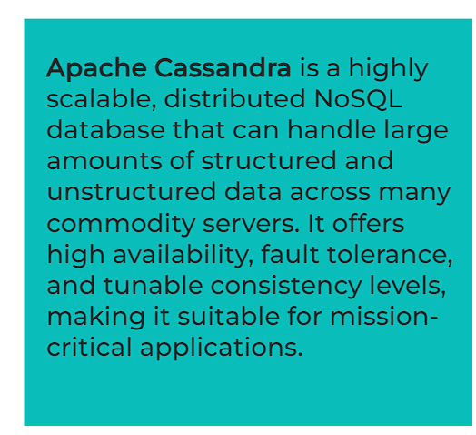 (highly scalable, distributed NoSQL databaseare chosen for their scalability and flexibility with unstructured or semi-structured data.
  + **File-Based Tools**: Systems like the **Hadoop File System (HDFS)** and cloud-based options like **Ceph** provides distributed and scalable storage solutions for big data applications.

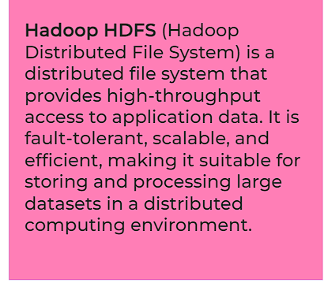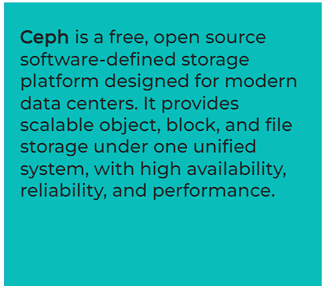

* + **Elasticsearch**: This tool is vital for **text data storage** and retrieval, facilitating the creation of search indices for fast and efficient document retrieval.

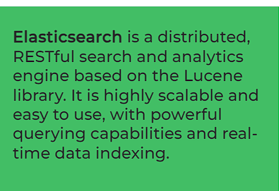

1. **Open-Source Data Integration and Transformation Tools**:
   * **Apache AirFlow**: Originally developed by **Airbnb**, it enables the creation and scheduling of data workflows, promoting efficient data integration and processing.
   * **KubeFlow**: Built on **Kubernetes**, it offers seamless execution of data science pipelines, providing scalability and orchestration capabilities.
   * **Apache Kafka**: A distributed streaming platform, often used for building **real-time data pipelines** and processing streams of data.
   * **Apache NiFi**: Known for its **visual interface**, it simplifies the design and management of data flows, enhancing data movement and transformation.
   * **Apache SparkSQL**: This component of **Apache Spark** enables SQL-based querying and processing of structured data, catering to diverse analytical needs.
   * **NodeRED**: With its intuitive visual editor, NodeRED facilitates the creation of **event-driven applications** and workflows, making it accessible even on resource-constrained devices like **Raspberry Pi**.
2. **Open-Source Data Visualization Tools**:
   * **Pixie Dust**: This Python library comes with a **user-friendly interface** for plotting and visualization, simplifying the visualization process for data scientists.

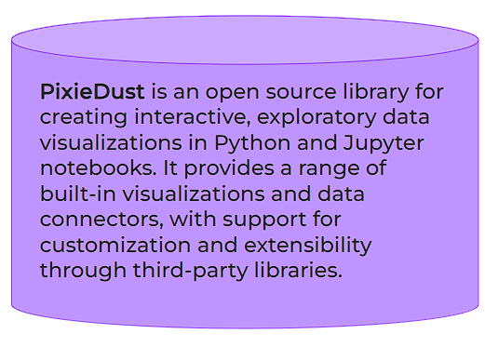

* + **Hue**: It enables the creation of visualizations directly from **SQL queries**, offering an intuitive interface for data exploration.

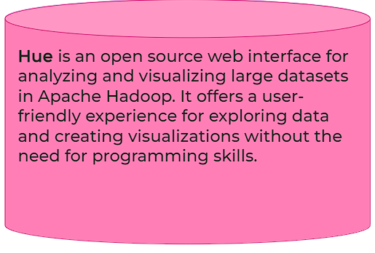

* + **Kibana**: Primarily used with **Elasticsearch**, Kibana is a web application tailored for **data exploration and visualization of large datasets**, providing rich visualization options.
  + **Apache Superset**: As a **data exploration and visualization web application**, Superset offers a wide array of visualization choices, supporting diverse analytical needs.

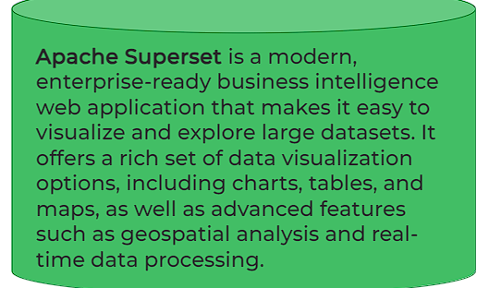

1. **Model Tools for Building, Deployment, Monitoring, and Assessment**:
   * **Apache PredictionIO**: This tool facilitates the **deployment of machine learning models(specially for recommendation, classification** and clustering especially those built with **Apache Spark ML**.

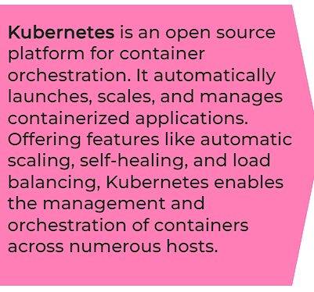

* + **Seldon**: With support for various frameworks like **TensorFlow**, **Apache SparkML**, and **scikit-learn**, Seldon simplifies model deployment on platforms like **Kubernetes** and **Redhat OpenShift**.

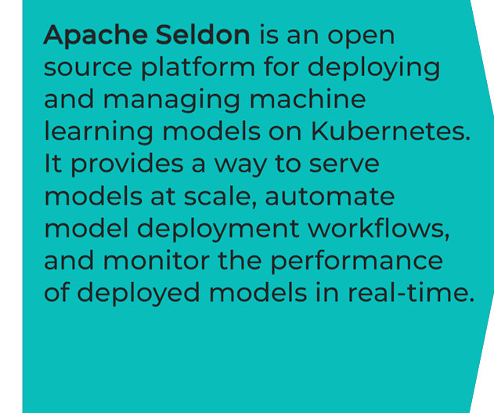

* + **MLeap**: Specifically designed for deploying **SparkML** models, MLeap ensures **interoperability** and scalability of deployed models.

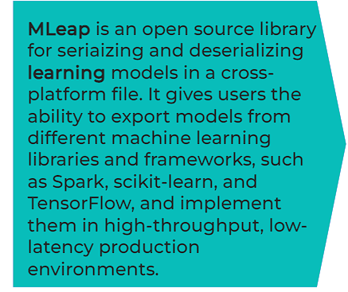

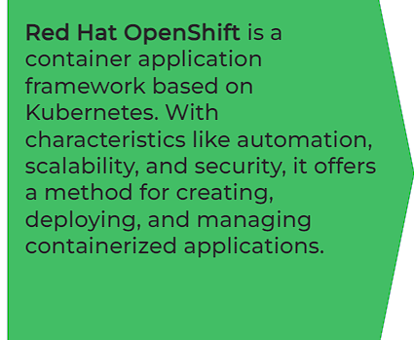

* + **TensorFlow**: This framework serves models for a wide range of platforms, including embedded devices, smartphones, and web browsers, thus ensuring **versatility** and **accessibility**. **To allow effective inference on mobile and embedded platforms**

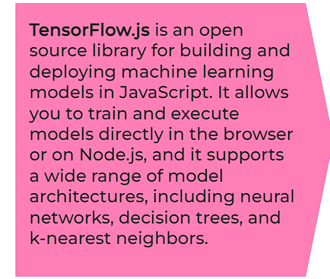

* + **ModelDB**: Serving as a **machine model metadata base**, ModelDB stores information about models, supporting popular frameworks like **Apache Spark ML Pipelines** and **scikit-learn**.

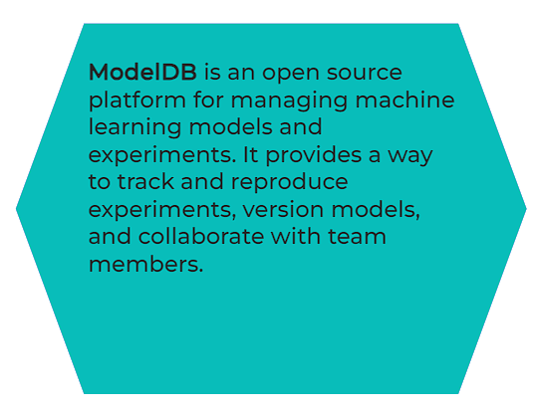

* + **Prometheus is widely used for machine learning model monitoring**

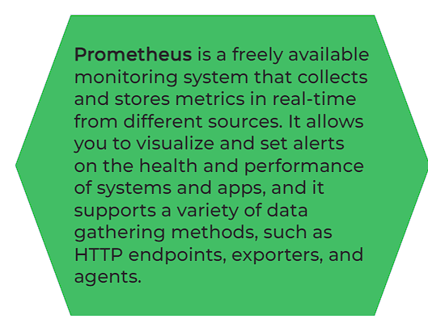

* + **IBM AI Fairness 360**: A toolkit dedicated to **detecting and mitigating bias** in machine learning models, addressing important ethical considerations.
  + 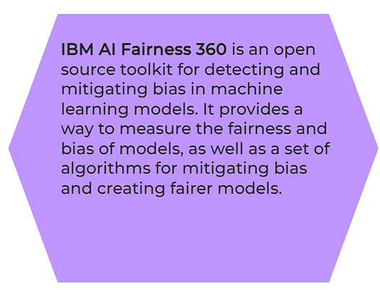
  + **IBM Adversarial Robustness 360 Toolbox**: It focuses on **detecting vulnerabilities** against adversarial attacks and enhancing model robustness, ensuring **security**. 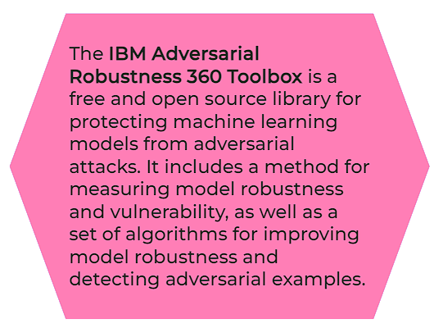
  + **IBM AI Explainability 360**: By addressing **model interpretability**, this toolkit aids in enhancing transparency and understanding of machine learning models, promoting trust and accountability.

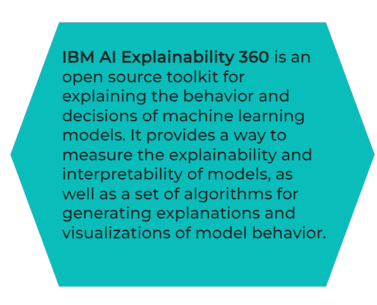

1. **Tools for Code and Data Asset Management**:
   * **Git**: As the **de facto standard** for version control, Git plays a pivotal role in managing code assets, with platforms like **GitHub**, **GitLab**, and **Bitbucket** offering additional services and collaboration features.

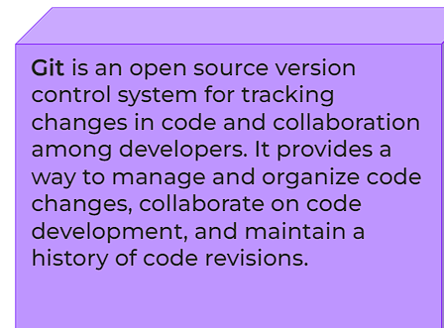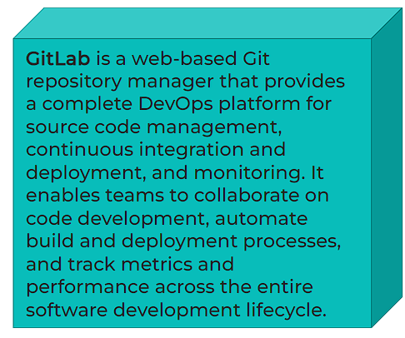

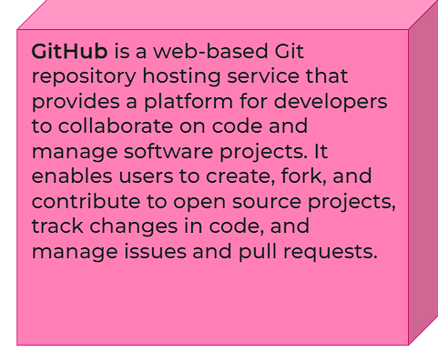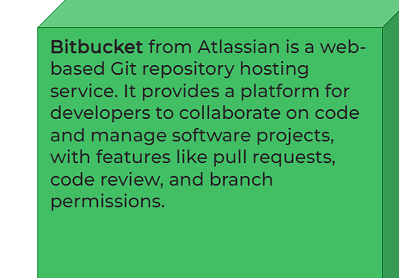

* + **Apache Atlas**: Supporting **data asset management** tasks, Apache Atlas allows for versioning and metadata annotation, ensuring **data governance** and **lineage**.

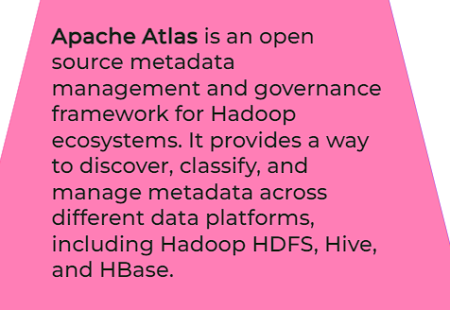

* + **ODPi Egeria**: Managed through the **Linux Foundation**, ODPi Egeria provides an open ecosystem with APIs and protocols for metadata repositories, promoting **interoperability** and **data exchange**.

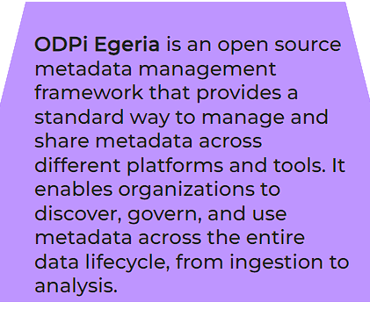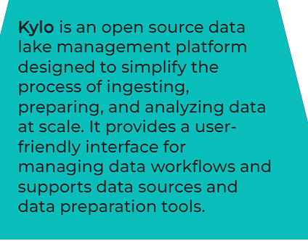

* + **Kylo**: An open-source data management platform, Kylo offers comprehensive support for data asset management, simplifying tasks related to **data governance** and **metadata management**.

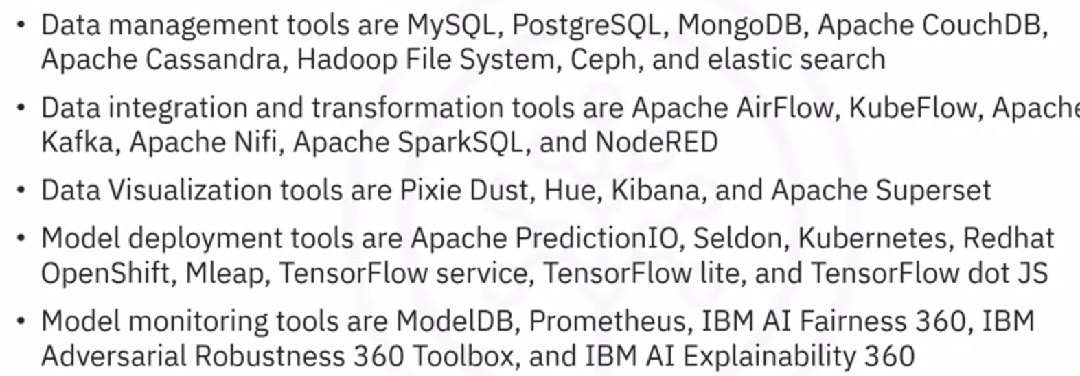

1. **Jupyter and Jupyter Lab**:
   * **Jupyter**: Originally developed as IPython in 2011, Jupyter is an open-source web application that allows users to create and share documents containing live code, equations, visualizations, and narrative text. It supports various programming languages(Julia R development, with Python being the most popular. Jupyter Notebooks provide an interactive environment where users can execute code snippets, visualize data, and document their analysis in a single document.

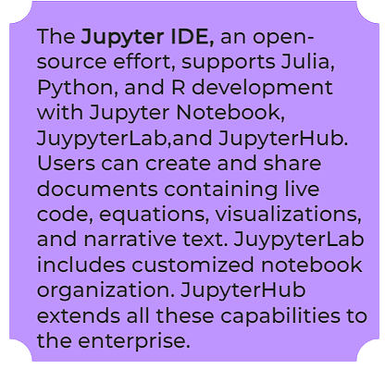

* + **Jupyter Lab**: Released as the next-generation interface for Jupyter Notebooks, Jupyter Lab offers a more integrated and extensible environment for interactive computing. It allows users to work with multiple documents, terminals, data files, and notebooks simultaneously, enhancing productivity and flexibility.

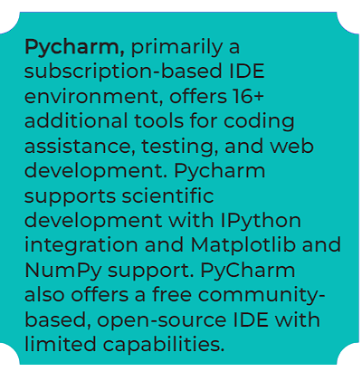

1. **Apache Zeppelin**:
   * **Apache Zeppelin**: Similar to Jupyter Notebooks, Apache Zeppelin is an open-source web-based notebook that supports interactive data analysis and visualization. It provides built-in support for various interpreters, enabling users to write code in languages such as Python, SQL, Scala, and more within the same notebook. One notable feature of Zeppelin is its integrated plotting capabilities, which eliminate the need for external libraries for basic visualizations.
2. **RStudio**:
   * **RStudio**: RStudio is an integrated development environment (IDE) specifically designed for the **R programming language**. **It supports version control and project management capabilities** In R environment, Python development is possible. It provides a user-friendly interface for **writing, executing, and debugging R code, along with features for data manipulation, exploration, and visualization**. RStudio is widely used by statisticians and data scientists for its comprehensive toolset and seamless integration with R packages.
3. **Spyder**:
   * **Spyder**: Spyder is an open-source IDE for **scientific computing in Python**. It offers features similar to RStudio but tailored for Python programming. Spyder includes a **code editor, variable explorer, debugger, and integrated plotting tools**, making it suitable for **data analysis, visualization, and exploration tasks**. While not as feature-rich as RStudio, Spyder provides a familiar environment for Python users.
4. **Cluster Execution Environments**: (when data does not fit in single main memory)
   * **Apache Spark**: (**which primarily focuses on batch processing**) Apache Spark is a fast and general-purpose distributed computing engine for big data processing. It provides **APIs for batch processing**, stream processing, machine learning, and graph processing, making it versatile for various data processing tasks. Spark's key feature is its **linear scalability**, allowing users to process large datasets across distributed clusters with high performance.(**more used)**
   * **Apache Flink**: Apache Flink is an open-source stream processing framework designed for real-time analytics and processing of continuous data streams. Unlike Spark, **which primarily focuses on batch processing**, Flink is optimized for stream processing, making it suitable for use cases requiring low-latency data processing and event-driven architectures.
   * **Ray** (**for large scale deep-learning model training)** Ray is a distributed execution framework designed for high-performance computing and machine learning tasks. It provides a simple and scalable API for parallel and distributed computing, making it ideal for large-scale deep learning model training and inference. Ray's focus on scalability and performance makes it well-suited for modern data science applications.

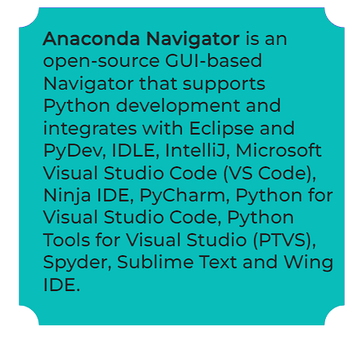

1. **Fully Integrated and Visual Tools**:
   * **KNIME**: KNIME is an open-source data analytics platform that allows users to visually design data workflows using a **drag-and-drop interface**. It offers a wide range of built-in tools and functionalities for data integration, transformation, analysis, and visualization. KNIME's visual approach makes it accessible to users with varying levels of programming expertise, while its extensibility allows for integration with other **tools and libraries, including R, Python, and Apache Spark.**
   * **Orange**: Orange is a visual programming tool for data analysis and machine learning. It provides a user-friendly interface for building data analysis workflows using visual components called widgets. Orange includes a variety of widgets for data preprocessing, visualization, modeling, and evaluation, making it suitable for users who prefer a simpler and more intuitive approach to data science tasks.

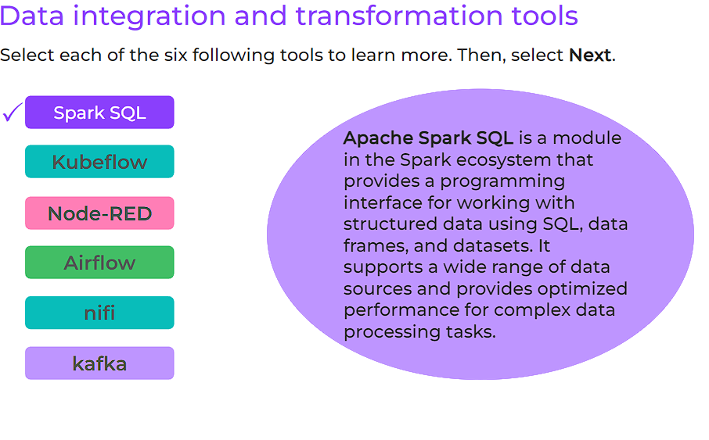

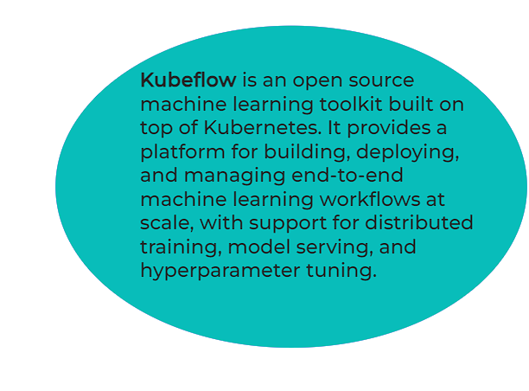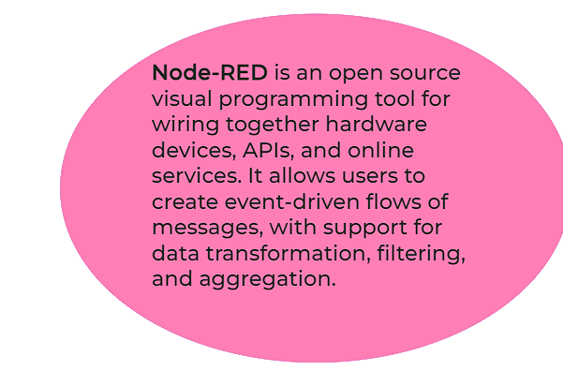

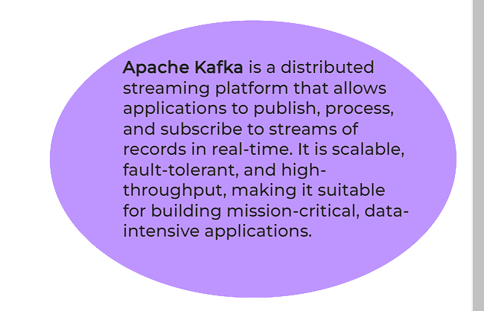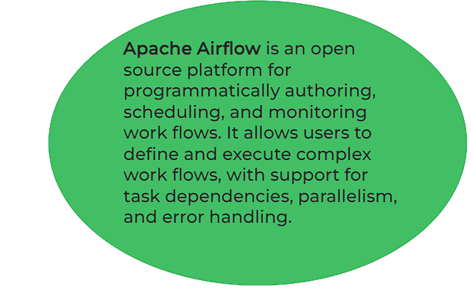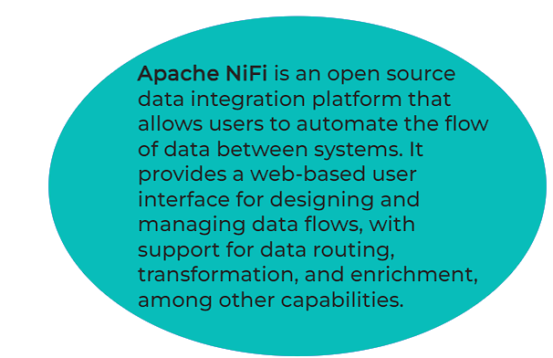

Certainly! Here's a comprehensive summary including all the points covered in the video:

1. **Data Management Tools:**
   * Industry-standard products include Oracle Database, Microsoft SQL Server, and IBM Db2.
   * Commercial support availability is crucial, and these products are backed by vendors, influential partners, and support networks.
2. **Data Integration Tools:**
   * Leading tools include Informatica PowerCenter and IBM InfoSphere DataStage according to Gartner Magic Quadrant.
   * Other notable products are from SAP, Oracle, SAS, Talend, Microsoft, and Watson Studio Desktop.
   * These tools facilitate extract, transform, and load (ETL) processes through a graphical interface and offer connectors to various target information systems.
3. **Data Visualization Tools:**
   * Business intelligence (BI) tools like Tableau, Microsoft Power BI, and IBM Cognos Analytics are prominent.
   * Visualization tools in Watson Studio Desktop cater to data scientists, focusing on showing relationships between different columns in tables.
4. **Model Building Tools:**
   * SPSS Modeler and SAS Enterprise Miner are significant data mining products for building machine learning models.
   * SPSS Modeler is available in Watson Studio Desktop as well.
5. **Model Deployment and Monitoring:**
   * Model deployment is integrated into the model-building process in commercial software like SPSS Collaboration and Deployment Services.
   * Exporting models in open formats like PMML is supported by commercial software.
   * Model monitoring is currently mainly addressed through open-source tools.
6. **Code Asset Management:**
   * Open-source tools like Git and GitHub are standard for code asset management.
7. **Data Asset Management:**
   * Tools like Informatica Enterprise Data Governance and IBM Information Governance Catalog handle data governance and data lineage tasks.
   * Features include data versioning, metadata annotation, data dictionary, data steward assignment, data lineage tracking, and rules/policies for regulatory and business requirements.
8. **Fully Integrated Development Environments:**
   * Watson Studio is a fully integrated development environment for data scientists, available in both cloud and desktop versions.
   * Watson Studio, together with Watson Open Scale, covers the data science lifecycle and can be deployed locally or on Kubernetes / RedHat OpenShift.
   * H2O Driverless AI is another example of a fully integrated commercial tool covering the complete data science lifecycle.

In summary, commercial tools offer comprehensive support for various tasks in data science, including data management, integration, visualization, model building, deployment, monitoring, code asset management, and data asset management. These tools provide functionalities tailored to different user needs and are backed by vendors, support networks, and open standards for interoperability.

1. **Commercial Data Management Tools:**
   * Oracle Database, Microsoft SQL Server, and IBM Db2 are widely recognized as industry-standard data management solutions.
   * These products are designed to store, manage, and retrieve large volumes of structured data efficiently.
   * They offer features such as transaction management, data integrity, security, and scalability.
   * Commercial support for these tools ensures organizations receive timely assistance, updates, and maintenance from software vendors and their partners.
   * Open-source databases are gaining popularity but may not always offer the same level of reliability, support, and enterprise features as commercial solutions.
2. **Commercial Data Integration and Transformation Tools:**
   * Informatica PowerCenter and IBM InfoSphere DataStage are leaders in the field of data integration and transformation, according to industry assessments like the Gartner Magic Quadrant.
   * These tools enable organizations to extract data from various sources, transform it according to business requirements, and load it into target systems.
   * Other notable products in this category include offerings from SAP, Oracle, SAS, Talend, Microsoft, and Watson Studio Desktop.
   * Features typically include graphical interfaces for designing ETL (Extract, Transform, Load) processes, connectors to diverse data sources, and scalability to handle large datasets.
3. **Data Visualization Tools:**
   * Business intelligence (BI) tools like **Tableau, Microsoft Power BI, and IBM Cognos Analytics are widely used for data visualization and analysis.**
   * These tools enable users to create interactive dashboards, reports, and visualizations to explore and communicate insights from data.
   * Watson Studio Desktop also provides visualization capabilities tailored for data scientists, allowing them to visualize relationships between different data columns efficiently.
4. **Model Tools for Building, Deployment, Monitoring, and Assessment:**
   * SPSS Modeler and SAS Enterprise Miner are leading data mining products used for building machine learning models.

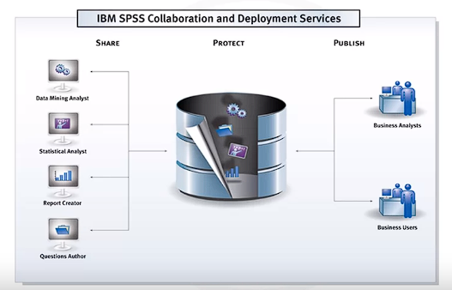

* + SPSS Modeler is available in Watson Studio Desktop, providing users with cloud-based model-building capabilities.
  + Model deployment is seamlessly integrated into the model-building process in commercial software like SPSS Collaboration and Deployment Services, allowing users to deploy models efficiently.
  + Commercial tools often support exporting models in open formats like PMML for interoperability with other software packages.
  + Model monitoring is a nascent discipline, and currently, open-source tools are often preferred for this task due to the lack of relevant commercial offerings.

1. **Tools for Code Asset Management:**
   * Git and GitHub are widely adopted as the de facto standard for code asset management in data science and software development.
   * These tools enable version control, collaboration, and tracking of changes to code repositories, ensuring code integrity and reproducibility.
2. **Data Asset Management Tools:**
   * Informatica Enterprise Data Governance and IBM Information Governance Catalog are examples of tools designed for data asset management, also known as data governance or data lineage.
   * These tools facilitate tasks such as data versioning, metadata annotation, data dictionary creation, data stewardship assignment, and data lineage tracking.
   * They help organizations ensure data quality, compliance, and transparency by documenting data assets, their ownership, and their lineage.
3. **Development Environment:**
   * Watson Studio provides a fully integrated development environment for data scientists, available in both cloud and desktop versions.
   * Watson Studio Desktop combines Jupyter Notebooks with graphical tools, maximizing the productivity of data scientists by offering a seamless environment for data exploration, analysis, and model development.
   * H2O Driverless AI is another example of a fully integrated commercial tool covering the complete data science lifecycle, from data preprocessing to model deployment.
4. **Fully Integrated Visual Tools:**
   * Watson Studio, together with Watson Open Scale, offers a fully integrated solution covering the entire data science lifecycle, including data management, integration, visualization, model building, deployment, monitoring, and assessment.
   * These tools can be deployed locally or on cloud platforms like Kubernetes / RedHat OpenShift, providing flexibility and scalability to organizations.
5. **Describe how commercial cloud tools support data science tasks:** Commercial cloud tools provide a range of services and platforms that support various aspects of data science tasks. These tools are hosted on cloud infrastructure and offer features such as data storage, processing, analysis, machine learning model development and deployment, data visualization, and more. They leverage the scalability and flexibility of cloud computing to handle large volumes of data and complex computations efficiently. Examples of such tools mentioned in the passage include Watson Studio, Microsoft Azure Machine Learning, H2O Driverless AI, and others.
6. **Explain how integration provides the ability to use the same tools for multiple tasks:** Integration refers to the capability of combining different functionalities or services within the same tool or platform. In the context of commercial cloud tools for data science, integration allows users to perform multiple tasks seamlessly within a single environment. For example, Watson Studio and Watson OpenScale cover the complete development lifecycle for data science, machine learning, and AI tasks, which means users can perform tasks such as data preparation, model development, deployment, monitoring, and optimization using the same integrated platform.
7. **Fully integrated visual tools category:** This category refers to tools that offer comprehensive features for visualizing data and executing data science workflows in a visual manner. These tools often include components for large-scale execution of data science tasks in compute clusters, making them suitable for handling big data analytics. Examples mentioned in the passage include Watson Studio, Watson OpenScale, Microsoft Azure Machine Learning, and H2O Driverless AI. These tools provide a range of visualization capabilities and support the development of machine learning and AI models.
8. **Data management:** In the realm of data management, cloud providers offer software-as-a-service (SaaS) versions of existing open-source and commercial tools. These tools help organizations manage their data efficiently, including tasks such as storage, retrieval, backup, restoration, and scaling. Examples cited in the passage include Amazon Web Services DynamoDB, Cloudant, and IBM Db2. These services relieve users of the operational burden associated with managing databases and provide seamless integration with cloud environments.
9. **Commercial data integration tools:** Data integration tools play a crucial role in combining and transforming data from multiple sources into usable formats for analysis and decision-making. Commercial cloud tools such as Informatica Cloud Data Integration and IBM’s Data Refinery offer features for extract, transform, and load (ETL) as well as extract, load, and transform (ELT) processes. These tools empower data scientists and engineers to perform data integration tasks efficiently without relying heavily on dedicated data integration teams.
10. **Cloud-based data visualization tools:** Visualization is essential for understanding and communicating insights derived from data analysis. Cloud-based data visualization tools like Datameer and IBM’s Cognos Business Intelligence suite provide capabilities for creating interactive and informative visualizations from various data sources. These tools enable users to explore data, identify patterns, and communicate findings effectively within their organizations.
11. **Model building using services:** Cloud-based services such as Watson Machine Learning and Google AI Platform Training offer platforms for building, training, and deploying machine learning models. These services provide access to various open-source libraries and tools, allowing data scientists to experiment with different algorithms and techniques without worrying about infrastructure management. Users can train models using large datasets and deploy them for inference in production environments seamlessly.
12. **Model deployment and monitoring:** Deploying and monitoring machine learning models in production is critical for ensuring their performance and reliability over time. Cloud tools like SPSS Collaboration and Deployment Services, Amazon SageMaker Model Monitor, and Watson OpenScale offer features for deploying, monitoring, and managing machine learning models at scale. These tools provide capabilities for continuous monitoring of model performance, detecting drift, and ensuring regulatory compliance, thereby enabling organizations to maintain the effectiveness of their AI-driven applications.

Top of Form

**Criteria for Determining the Language to Learn:**

1. **Needs and Problems to Solve:**
   * Different programming languages excel in different areas of data science, such as data manipulation, analysis, visualization, or machine learning.
   * For instance, Python is widely used for its versatility in data handling, while R is popular for statistical analysis, and SQL is essential for database querying and manipulation.
   * 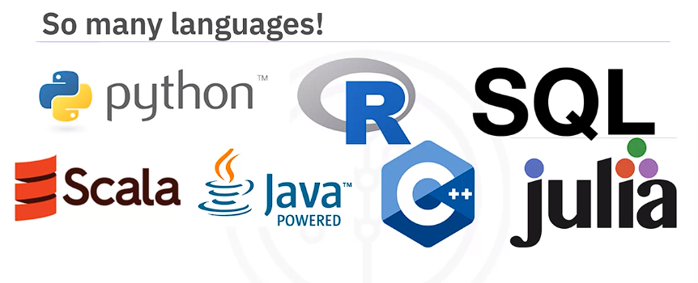
   * Choosing the right language depends on the specific requirements and objectives of your projects.
2. **Target Audience:**
   * Consideration of who will benefit from your data science work can influence the choice of language.
   * For example, if your audience consists of software engineers, a language like **Python may be preferable due to its readability and widespread adoption.**
   * Conversely, if your audience includes statisticians or data analysts, R might be more suitable due to its extensive statistic al libraries and functionality.

**Roles Involved in Data Science:**

1. **Business Analyst:**
   * Analyzes data to provide insights into business operations, market trends, and consumer behavior.
   * Uses tools such as data visualization and reporting software to communicate findings to stakeholders and support decision-making processes.
2. **Database Engineer:**
   * Designs, implements, and maintains database systems to ensure efficient data storage, retrieval, and management.
   * Optimizes database performance and scalability while adhering to data security and integrity standards.
3. **Data Analyst:**
   * Examines data sets to identify patterns, trends, and correlations that can inform business strategies and initiatives.
   * Utilizes statistical analysis and data visualization techniques to present findings in a clear and actionable manner.
4. **Data Engineer:**
   * Develops and maintains data pipelines and infrastructure to ingest, process, and transform large volumes of data.
   * Implements data integration solutions and ensures data quality, consistency, and reliability across different systems and platforms.
5. **Data Scientist:**
   * Applies advanced statistical and machine learning techniques to extract insights and build predictive models from data.
   * Develops algorithms and conducts experiments to solve complex business problems and optimize decision-making processes.
6. **Research Scientist:**
   * Conducts research to explore new methodologies, algorithms, and technologies in data science and related fields.
   * Publishes findings in academic journals and collaborates with industry partners to apply research discoveries in real-world contexts.
7. **Software Engineer:**
   * Designs, develops, and maintains software applications and systems that leverage data for various purposes, such as analytics, automation, and decision support.
   * Implements algorithms and data structures to optimize performance and scalability in data-intensive applications.
8. **Statistician:**
   * Applies statistical methods and techniques to analyze data, infer relationships, and make predictions about future outcomes.
   * Provides expertise in experimental design, sampling methods, and hypothesis testing to support data-driven decision-making processes.
9. **Product Manager:**
   * Oversees the development and management of data-related products and services, from conception to delivery.
   * Collaborates with cross-functional teams to define product requirements, prioritize features, and ensure alignment with customer needs and business goals.
10. **Project Manager:**
    * Manages data science projects from initiation to completion, including planning, execution, monitoring, and closing phases.
    * Coordinates resources, timelines, and deliverables to ensure projects are completed on time, within budget, and according to specifications.

These roles encompass a broad spectrum of skills, expertise, and responsibilities within the field of data science, reflecting the interdisciplinary nature of the discipline and the diverse tasks involved in working with data.

Certainly! Let's delve deeper into each point:

**Users of Python:**

1. **Programmers familiar with other languages:**
   * Python's clear and readable syntax makes it appealing to programmers who are already familiar with other programming languages.
   * Its simplicity and elegance make it easier for programmers to write and maintain code, reducing the learning curve for those transitioning from other languages.
2. **Beginners:**
   * Python is often recommended as a first programming language for beginners due to its simplicity and ease of learning.
   * The extensive global community and wealth of documentation make it easier for beginners to find resources, tutorials, and support when learning Python.
   * Its readability and simplicity allow beginners to focus on learning programming concepts rather than getting bogged down in complex syntax.
3. **Data professionals:**
   * Python has become the language of choice for many data professionals, with over 80% of data professionals worldwide reported to use Python.
   * Its extensive libraries and frameworks tailored for data science, machine learning, and analytics tasks make it a powerful tool for data professionals.
   * Python's versatility allows data professionals to perform various tasks, including data cleaning, analysis, visualization, and model building, all within the same language and ecosystem.

**Benefits of Using Python:**

1. **Clear and readable syntax:**
   * Python's syntax is designed to be clear, concise, and readable, making it easier for developers to write and understand code.
   * Its indentation-based block structure promotes clean and organized code, reducing the likelihood of syntax errors and improving code maintainability.
2. **Extensive global community and documentation:**
   * Python has a large and active global community of developers, enthusiasts, and contributors who provide support, resources, and guidance to users.
   * The wealth of documentation available for Python libraries, frameworks, and tools makes it easier for users to find answers to their questions, troubleshoot issues, and learn new concepts.
3. **Widely applicable in various fields:**
   * Python's versatility allows it to be used in a wide range of applications and industries, including data science, artificial intelligence, web development, scientific computing, and more.
   * Its cross-platform compatibility and extensive library ecosystem make it suitable for developing software solutions across different platforms and domains.
4. **Comprehensive standard library:**
   * Python comes with a comprehensive standard library that provides a wide range of modules and packages for various tasks**, including database access, automation, web scraping, text processing, image processing, and more.**
   * This rich set of built-in tools reduces the need for external dependencies and simplifies development by providing ready-to-use solutions for common programming tasks.
5. **Scientific computing libraries for data science:**
   * Python offers powerful libraries and frameworks for data science tasks, including **Pandas for data manipulation, NumPy for numerical computing, SciPy for scientific computing, and Matplotlib for data visualization.**
   * These libraries provide efficient and intuitive tools for data analysis, exploration, visualization, and modeling, making Python a preferred choice for data scientists.
6. **Support for artificial intelligence tasks:**
   * Python has emerged as a leading language for artificial intelligence and machine learning applications, with libraries such as TensorFlow, PyTorch, Keras, and Scikit-learn providing robust support for building and training machine learning models.
   * These libraries offer a wide range of algorithms, tools, and utilities for tasks such as neural network modeling, deep learning, reinforcement learning, and more.
7. **Natural Language Processing (NLP) capabilities:**
   * Python supports Natural Language Processing (NLP) tasks through libraries like **NLTK (Natural Language Toolkit)**, providing tools and algorithms for processing and analyzing textual data.
   * These libraries enable developers to build applications for tasks such as text classification, sentiment analysis, language translation, and information extraction, leveraging the power of Python's ecosystem for NLP tasks.

**Diversity and Inclusion Efforts of the Python Community:**

1. **Python Software Foundation's code of conduct:**
   * The Python Software Foundation (PSF) enforces a code of conduct that promotes safety, inclusivity, and diversity in Python communities, both online and in-person.
   * This code of conduct sets expectations for behavior and interactions within the Python community, fostering an environment where all individuals feel welcome and respected.
2. **Initiatives like PyLadies:**
   * PyLadies is an international mentorship group focused on helping more women become active participants and leaders in the Python open-source community.
   * PyLadies organizes events, workshops, and mentorship programs to create opportunities for women to learn and contribute to Python projects in a supportive and inclusive environment.
   * By providing resources, networking opportunities, and mentorship, PyLadies aims to address gender disparities in the tech industry and promote diversity and inclusion within the Python community.

**Similarities between open source and free software:**

1. **Free to Use:**
   * Both open source and free software are freely available for use by anyone without cost. Users can download, install, and distribute the software without needing to pay any licensing fees.
2. **Common Licenses:**
   * Open source and free software often utilize similar licenses, such as the General Public License (GNU), which grants users the freedom to use, modify, and distribute the software.
3. **Support for Collaboration:**
   * Both open source and free software encourage collaboration among developers and users. They often have communities where users can contribute code, report bugs, and suggest improvements to the software.

**Differences between open source and free software:**

1. **Organizational Champions:**
   * The Open-Source Initiative (OSI) advocates for the open-source model, emphasizing **transparency, peer review, and collaboration.**
   * The Free Software Foundation (FSF) defines free software based on principles of **freedom, emphasizing users' rights to study, modify, and share software**.
2. **Focus and Values:**
   * Open source tends to focus more **on practical benefits and business advantages, such as cost savings, flexibility, and innovation.**
   * Free software places a stronger emphasis **on ethical values, such as user freedom**, **social responsibility**, and **community empowerment**.

**Users of the R language:**

1. **Statisticians, Mathematicians, and Data Miners:**
   * R is widely used by professionals in fields such as statistics, mathematics, and data mining for developing statistical software, conducting data analysis, and creating visualizations.
2. **Popular in Academia:**
   * R is a popular choice among **researchers, academics, and students in universities and research institutions for its extensive statistical capabilities and flexibility.**
3. **Adoption in Industry:**
   * Many companies across various industries utilize R for tasks such **as financial analysis, predictive modeling, customer segmentation, and business intelligence.**

**Benefits of using R:**

1. **Free Software:**
   * R is **free software, meaning users have the freedom to use, modify, and distribute the software without restrictions, aligning with the principles of free software advocacy.**
2. **Accessibility and Ease of Learning:**
   * R's **array-oriented syntax** simplifies the translation of mathematical concepts into code, making it accessible to users with minimal programming experience or background.
3. R is the largest repository of statistical knowledge
4. **Extensive Package Ecosystem:**
   * R boasts a vast repository of over 15,000 publicly released packages, providing users with a wide range of tools and functionalities for data analysis, visualization, modeling, and more.
5. **Integration and Interoperability:**
   * R integrates seamlessly with other programming languages such **as C++, Java, and Python,** allowing users to leverage existing libraries and frameworks for specific tasks.
6. **Object-Oriented Programming Support:**
   * R offers robust support for object-oriented programming (OOP), enabling users to create and manipulate objects, classes, and methods for more structured and modular code development.

**Global communities for connecting with other R users:**

1. **Specialized Communities:**
   * Platforms such as **useR,** **WhyR, SatRdays, and R-ladies** provide specialized forums, meetups, and events for R users to connect, collaborate, and share knowledge.
2. **Conferences and Events:**
   * The R project website hosts information on R conferences, workshops, and seminars held worldwide, allowing users to stay updated on upcoming events and opportunities for networking and learning.

**Introduction to SQL:**

Pronunciation and Origin:

* Officially pronounced as "ess cue el," though some refer to it as "sequel."
* Acronym stands for "Structured Query Language."
* Developed at **IBM in 1974, making it older than Python and R by about 20 years**.

Purpose and Scope:

* SQL is a non-procedural language primarily used for querying and managing data.
* It is essential in handling structured data, particularly in relational databases.
* While originally designed for relational databases, SQL interfaces exist for various NoSQL and big data repositories.

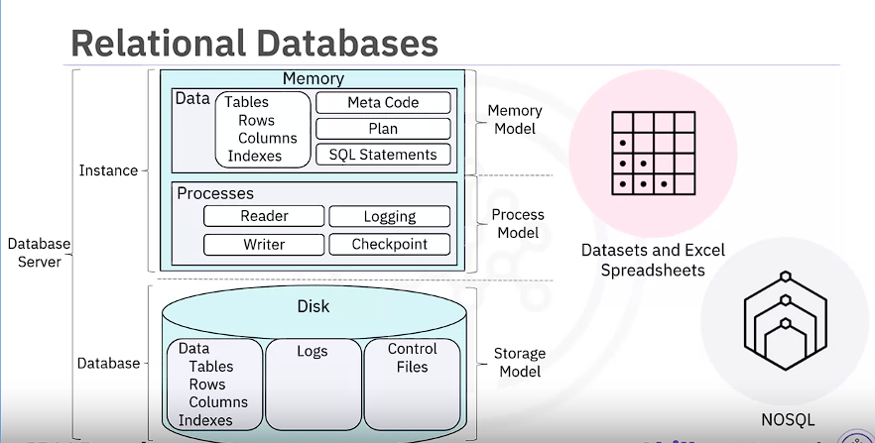

SQL Language Elements:

* **Clauses:** Various components of SQL queries, such as SELECT, FROM, WHERE, etc.
* **Expressions:** Combinations of symbols and operators that evaluate to a single value.
* **Predicates:** Conditions used to filter data in SQL queries.
* **Queries:** Statements used to retrieve data from a database.
* **Statements:** Instructions that perform actions such as data manipulation or database schema modifications.

Benefits of Using SQL:

* **Versatility in Job Opportunities:**
  + Knowledge of SQL opens doors to various roles in data science, including business and data analysts, and data engineering.
* **Direct Data Access:**
  + SQL allows **direct access to data without the need for separate data copying,** speeding up workflow executions.
* **Standardization:**
  + **SQL is an American National Standards Institute (ANSI) standard, ensuring compatibility across different databases.**
* **Ease of Learning and Applicability:**
  + Learning SQL with one database allows for easy application of skills to other databases.
* **Availability of SQL Databases:**
  + Various SQL databases are available, including MySQL, PostgreSQL, Oracle, Microsoft SQL Server, etc., providing options for different needs and preferences.

Learning SQL:

* **Focus on Specific Database:**
  + It's beneficial to focus on a specific relational database when learning SQL.
  + Syntax may vary based on the database management system being used.
* **Community Engagement:**
  + Engaging with the community for a specific platform can provide valuable support and resources.
* **Introductory Courses:**
  + Many introductory courses are available to learn SQL, offering a structured approach for beginners.

Top of Form

Certainly! Let's delve deeper into each language and its relevance to data science:

**Java:**

* **General-purpose Object-Oriented Language:**
  + Java is renowned for its **versatility and scalability,** making it a popular choice in enterprise environments.
  + Its object-oriented nature promotes code reuse, modularity, and maintainability.
* **Data Science Tools:**
  + **Weka:** A comprehensive suite for **data mining tasks**, offering algorithms for classification, regression, clustering, and more.
  + **Java-ML:** Provides a wide range of machine learning algorithms and tools for data **preprocessing, feature selection, and model evaluation.**
  + **Apache MLlib:** A scalable **machine learning library built on Apache Spark**, enabling distributed machine learning tasks on large datasets.
  + **Deeplearning4:** A deep learning library that facilitates the development of neural networks and deep learning models.
* **Hadoop:**
  + While not a data science tool per se, Hadoop is instrumental **in big data processing** **and storage**, making **it indispensable for large-scale data analytics tasks.**

**Scala:**

* **General-purpose Language with Functional Programming Support:**
  + Scala combines **object-oriented and functional programming paradigms, offering flexibility and expressiveness**.
  + It runs on the **Java Virtual Machine (JVM) and seamlessly interoperates with Java libraries.**
* **Data Science Tool:**
  + **Apache Spark:** A **distributed computing system** that provides **high-level APIs for parallel data processing.** It includes modules like **Shark (query engine), MLlib (machine learning), GraphX (graph processing), and Spark Streaming (real-time data processing).**

**C++:**

* **General-purpose Language with Enhanced Processing Speed:**
  + C++ is renowned for its performance and efficiency, making it suitable for computationally intensive tasks.
  + It **offers low-level control over hardware** resources and memory management.
* **Data Science Applications:**
  + **TensorFlow:** A popular deep learning framework developed by Google, with a **C++ backend** for efficient computation of neural network operations.
  + **MongoDB:** A NoSQL database designed for big data management, built with C++ for performance and scalability.
  + **Caffe:** A deep learning library known for its speed and modularity, implemented in C++ with Python and Matlab bindings.

**JavaScript:**

* **General-purpose Language with Widespread Use:**
  + JavaScript is ubiquitous, primarily known for its role in web development. However, with the advent of Node.js, it has extended to server-side applications.
* **Data Science Tools:**
  + **TensorFlow.js:** Allows machine learning and deep learning tasks to be performed in Node.js and web browsers, leveraging the TensorFlow framework.
  + **R-js:** Translates linear algebra specifications from R into TypeScript, paving the way for powerful mathematical frameworks in JavaScript.

**Julia:**

* **High-performance Language for Numerical Analysis:**
  + Julia is designed for high-performance numerical computing, combining the ease of use of dynamic languages like Python with the speed of statically compiled languages like C or Fortran.
* **Data Science Application:**
  + **JuliaDB:** A package tailored for working with large persistent datasets, showcasing Julia's potential for data science tasks.

**Conclusion:**

* Each language offers distinct advantages and is suited to different aspects of data science, ranging from data preprocessing and analysis to model development and deployment.
* Understanding the strengths and ecosystems of these languages allows data scientists to select the most appropriate tools for their specific requirements and optimize their workflows for efficiency and productivity.

***Libraries are a collection of functions and methods that allow you to perform many actions without writing the code.***

**Scientific Computing Libraries/Framework in Python:**

1. **Pandas: (is built on top of numpy)**
   * **Functionality:** Pandas is a powerful library that facilitates **data manipulation, analysis, and cleaning in Python.**
   * **Data Structures:** It offers data structures like Series (one-dimensional labeled array) and **DataFrame (two-dimensional labeled data structure with columns of potentially different types).**
   * **Features:** Pandas provides tools for indexing, merging, reshaping, and handling missing data, making it indispensable for data preprocessing tasks in data science projects.
   * **Usage:** It's extensively used for data exploration, data wrangling, and preparing data for analysis or modeling.
2. **NumPy:( Arrays & matrices)**
   * **Array Operations:** NumPy is fundamental for numerical computing in Python, providing support for **large, multi-dimensional arrays and matrices**.
   * **Efficiency:** It allows efficient mathematical operations on arrays, making it suitable for scientific computing tasks.
   * **Integration:** Many other Python libraries, including Pandas, rely on NumPy for array-based computations, enhancing their performance and functionality.
   * **Applications:** NumPy is widely used in array computing, linear algebra, statistical analysis, and more.

**Visualization Libraries in Python:**

1. **Matplotlib:**
   * **Versatility:** Matplotlib is a comprehensive library for creating static, interactive, and animated visualizations in Python.
   * **Customization:** It offers extensive customization options for plots, allowing users to control every aspect of the visualization, from colors and labels to axes and annotations.
   * **Publication-Quality Plots:** Matplotlib enables the creation **of high-quality plots** and graphs suitable for publications, presentations, and reports.
   * **Usage:** It's widely used for generating line plots, scatter plots, histograms, bar charts, pie charts, and more.
2. **Seaborn:( Based on Matplotlib)**
   * **Statistical Visualization:** Seaborn is built on top of Matplotlib and provides a higher-level interface for creating attractive and informative statistical graphics.
   * **Ease of Use:** It simplifies the creation of complex visualizations, such as heatmaps, pair plots, violin plots, and regression plots.
   * **Integration:** Seaborn seamlessly integrates with Pandas DataFrames, making it easy to visualize relationships between variables in datasets.
   * **Applications:** Seaborn is commonly used for exploratory data analysis, visualizing distributions, and identifying patterns in data.

**High-Level Machine Learning and Deep Learning Libraries in Python:**

1. **Scikit-learn: (built on numpy, scipy, and matplotlib)**
   * **User-Friendly Interface:** Scikit-learn provides a simple and consistent API for various **machine learning tasks, including classification, regression, clustering, and dimensionality reduction.**
   * **Efficiency:** It's built on top of NumPy, SciPy, and Matplotlib, ensuring high performance and scalability.
   * **Model Evaluation:** Scikit-learn offers tools for model selection, hyperparameter tuning, and cross-validation, facilitating the evaluation and comparison of different algorithms.
   * **Applications:** It's widely used in both academia and industry for building and deploying machine learning models across various domains.
2. **Keras:**
   * **Simplicity:** Keras offers a user-friendly interface for building and **training deep learning models with minimal code complexity.**
   * **Modularity:** It supports building complex neural networks by assembling reusable building blocks called layers.
   * **Flexibility:** Keras provides support for both CPU and GPU computation, allowing seamless scaling of deep learning tasks.
   * **Integration:** It seamlessly integrates with TensorFlow, making it easy to leverage TensorFlow's backend for efficient computation.

**Deep Learning Libraries in Python:**

1. **TensorFlow: ?(Not good for experminetation)**
   * **Low-Level Framework:** TensorFlow is a comprehensive framework for building and training deep learning models at scale.
   * **Production-Ready:** It's designed for large-scale production deployment, offering robust support for model serving, monitoring, and optimization.
   * **Flexibility:** TensorFlow allows for fine-grained control over model architecture and optimization strategies, making it suitable for research and experimentation.
   * **Community Support:** It boasts a large and active community, contributing to its extensive documentation, tutorials, and third-party libraries.
2. **PyTorch:**
   * **Dynamic Computation Graphs:** PyTorch adopts a dynamic computation graph approach, allowing for more flexible and intuitive model development.
   * **Ecosystem:** It offers a rich ecosystem of libraries and tools for building, training, and deploying deep learning models.
   * **Research Focus:** PyTorch is favored by researchers for its ease of use, flexibility, and support for imperative programming paradigms.
   * **Interoperability:** It seamlessly integrates with popular Python libraries like NumPy and Matplotlib, facilitating data preprocessing and visualization tasks.

**Libraries used in other languages:**

1. **Apache Spark: similar functionalities to (Pandas, NumPy, Scikit-learn)**
   * **Cluster Computing:** Apache Spark is a distributed computing framework that enables parallel data processing across large clusters of machines.
   * **Functionality:** It provides high-level APIs for various data processing tasks, including data manipulation, querying, machine learning, and stream processing.
   * **Language Support:** Spark supports multiple programming languages, including **Python, R, Scala, and SQL,** making it accessible to a wide range of users.
2. **Scala Libraries:**
   * **Vegas:** A Scala library for statistical data visualizations, offering capabilities for working with data **files and Spark DataFrames**.
   * **Data Engineering:** Scala is predominantly used in data engineering and data science for its scalability, performance, and interoperability with Apache Spark.
3. **R Libraries:**
   * **ggplot2:** A popular R package for creating elegant and customizable data visualizations, widely used in data analysis and exploration.
   * **Deep Learning:** R also offers libraries like **BigDL for deep learning tasks**, allowing users to leverage the power of deep neural networks in R environments.

**Definition of API:**

* **Application Programming Interface (API):** It facilitates communication between two software components by **defining a set of rules and protocols**. APIs allow programs to interact with each other without requiring knowledge of the underlying implementation details.

**API Libraries:**

* **Example of Pandas Library:**
  + **Usage:** The Pandas library is used for data manipulation and analysis in Python.
  + **API Usage:** Developers interact with the Pandas API to perform operations on data, such as filtering, aggregating, and transforming.
  + **Backend Implementation:** Although **not all components of Pandas are written in Python,** developers can use the Python API to access and manipulate data through other software components.
* **TensorFlow API:**
  + **Usage:** TensorFlow is a popular deep learning framework.
  + **Language Support:** It provides APIs for various programming languages, including Python, JavaScript, C++, Java, and Go.
  + **Backend Implementation:** TensorFlow's core functionality **is implemented in C++,** but it exposes APIs for different languages to facilitate integration with diverse software ecosystems.

**REST API:**

* **Definition:** Representational State Transfer (REST) **APIs enable communication over the internet and allow clients to interact with web services to access resources like storage, data, and algorithms.**
* **Client-Server Interaction:** In a REST API architecture, the client(**Our program)** interacts with a web service via HTTP requests and receives responses containing requested data or operations.
* **Key Terms:**
  + **Client:** Refers to the **entity or code making requests to the web service**.
  + **Resource:** Represents the **web service or endpoint** accessed by the client.
  + **Endpoint:** The **URL through** which the client **accesses the web service**.
* **HTTP Methods:** Requests and responses in REST APIs are transmitted using HTTP methods, such as **GET, POST, PUT, DELETE, etc.**
* **Data Transmission:** Data is transmitted between the client and the web service **using JSON files within HTTP messages.**

**Examples of REST APIs:**

* **Watson Text to Speech API:**
  + **Functionality:** Converts speech to text.
  + **API Call:** Involves sending an audio file to the API via a **POST request**, which returns the **text transcription** of the speech.
  + **Backend Operation:** The API processes the audio file and returns **the transcription using a GET request.**
* **Watson Language-Translator API:**
  + **Functionality:** Translates text from one language to another.
  + **API Call:** Involves sending text to the API, which returns the translated text.
  + **Example:** Translating English text to Spanish using the Watson Language-Translator API.

Certainly! Here's an elaboration on each key point extracted from the passage:

1. **Definition of a Dataset:**
   * A dataset refers to **a structured collection of data that contains various types of information, including text, numerical values, and media files such as images, audio, or video.**
   * Tabular datasets, which are common in data science, are organized in rows and columns. These datasets are often stored in formats like **CSV (comma-separated values).**
   * **A csv file is a delimited text file where each line represents a row, and a comma separates data values**
   * For example, in a weather dataset**, each row might represent an observation at a specific time,** while columns would contain data **such as temperature, humidity, and other weather conditions.**
2. **Types of Data Ownership:**
   * Traditionally, datasets were considered private, containing sensitive or proprietary information like **customer data, pricing data, or trade secrets**.
   * However, there's been a shift towards making certain datasets publicly available as "open data." These datasets are provided freely by public and private entities for various purposes such as research, analysis, and application development.
3. **Hierarchical data is stored in tree-like format** while **network data is stored in graphs**
4. **Sources of Data:**
   * Data can be sourced from a wide range of entities, including scientific institutions, governments, organizations, and companies.
   * Publicly available datasets can be found on websites of entities such as the United Nations, governmental agencies, intergovernmental organizations, and platforms like **Kaggle and Google**.
   * These datasets cover diverse fields such as economy, society, healthcare, transportation, and the environment, providing valuable resources for data scientists, researchers, and analysts.
5. **Community Data License Agreement (CDLA):**
   * The CDLA, developed by the Linux Foundation, addresses issues related to the distribution and use of open data.
   * It offers two main types of licenses: CDLA-Sharing and CDLA-Permissive.
   * CDLA-Sharing requires that any modifications made to the data must be shared under the same license terms as the original data.
   * CDLA-Permissive allows modifications without the requirement of sharing changes.
   * Importantly, CDLA licenses do not impose restrictions on the results derived from using the data, which is crucial in the context of data science projects.
6. **Impact of Open Data on Data Science:**
   * Open data plays a fundamental role in data science by providing practitioners with access to valuable resources for analysis, research, and application development.
   * The availability of open datasets has contributed to the growth of data science, machine learning, and artificial intelligence fields by enabling practitioners to uncover insights and develop innovative solutions.
   * While open datasets offer significant benefits, it's essential to consider potential business impacts, as certain datasets may not meet enterprise requirements due to sensitivity or proprietary concerns.

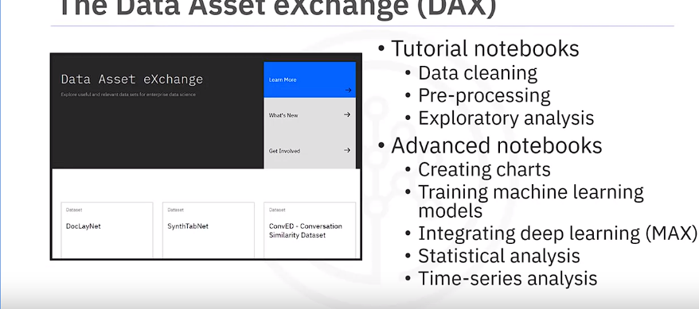

Certainly! Here's a detailed elaboration of the key points extracted from the passage:

1. **Introduction to Data Asset eXchange (DAX):**
   * The Data Asset eXchange (DAX) serves as IBM's platform for hosting an extensive collection of open datasets. It is specifically designed to cater to the needs of enterprises seeking curated, high-quality data for their applications.
   * DAX offers a centralized repository where users can access a diverse range of datasets sourced **from IBM Research as well as trusted third-party providers**. These datasets **encompass various types of data, including images, videos, text documents, and audio files.**
2. **Purpose of DAX:**
   * One of the primary objectives of DAX is to facilitate data sharing and collaboration within the enterprise environment. By providing datasets under the Community Data License Agreement (CDLA), DAX promotes openness and transparency in data usage.
   * DAX aims to streamline the process for developers and data scientists to acquire valuable datasets for their projects. It achieves this by curating datasets and offering tutorial notebooks that guide users through different **stages of data processing and analysis.**
3. **Features of DAX:**
   * DAX includes tutorial notebooks that cater to both novice and experienced users. These notebooks cover fundamental concepts such as data cleaning and pre-processing, as well as advanced topics like machine learning model training and statistical analysis.
   * In addition to tutorial notebooks, DAX integrates with the Model Asset eXchange (MAX), providing access to pre-trained deep learning models. This integration enables developers to incorporate state-of-the-art AI models into their applications seamlessly.
   * Both DAX and MAX are accessible through the IBM Developer website, providing developers with a comprehensive platform for building end-to-end analytic and machine learning workflows.
4. **Exploring DAX:**
   * Users can explore the datasets available on DAX by visiting the IBM Developer website and navigating to the Data Asset eXchange section. Here, they can browse through a diverse collection of open datasets curated for various use cases.
   * Upon identifying a dataset of interest, users can access detailed information about the dataset, including its description, source, and usage terms. They can also download the dataset directly from the platform for further analysis.
5. **Accessing Notebooks and Data Files:**
   * DAX datasets are accompanied by Jupyter Notebooks, which serve as instructional guides for performing data analysis tasks. These notebooks provide step-by-step instructions, code snippets, and visualizations to assist users in analyzing the dataset.
   * Users can execute the notebooks within Watson Studio, IBM's integrated environment for data science and AI, to perform tasks such as data cleaning, visualization, and model training.
   * Additionally, DAX datasets contain data files that users can access and incorporate into their projects. These data files are available for download and can be used for various purposes, depending on the specific requirements of the project.
6. **Summary of Learning:**
   * The video underscores the significance of DAX as a valuable resource for enterprises seeking access to high-quality open datasets. By providing curated datasets and tutorial notebooks, DAX empowers developers and data scientists to leverage open data effectively for their projects.
   * Users can interact with DAX to obtain, run, and preview datasets and associated notebooks, thereby enhancing their data exploration and analysis capabilities. Moreover, the integration with Watson Studio further facilitates seamless integration of datasets and models into end-to-end analytic workflows.

In essence, the Data Asset eXchange (DAX) plays a pivotal role in democratizing access to open data and fostering collaboration within the data science community, thereby advancing innovation and driving value creation in the enterprise landscape.

Certainly! Let's break down the key points and elaborate on each:

1. **Introduction to Machine Learning Models:**
   * Machine learning (ML) involves using algorithms or models to analyze data and identify patterns. These models are trained to recognize patterns by learning from example data, a process known **as "model training."** ML models can make predictions or decisions based on the patterns they've learned.
2. **Types of Machine Learning Models:**
   * **Supervised Learning:** This type of learning involves providing the model with labeled data, where each example is paired with a target output. The model learns to map inputs to outputs based on the provided examples. There are two main types of supervised learning:
     + **Regression Models:** These models predict **continuous numerical** values. For instance, predicting house prices based on **features like size and location.**
     + **Classification Models:** These models predict categories or labels. For example**, classifying emails as spam or not spam based on their content.**
   * **Unsupervised Learning:** In unsupervised learning, the model is given unlabeled data and must find patterns or structure within it without explicit guidance. Clustering and anomaly detection are common tasks in unsupervised learning.
   * **Reinforcement Learning:** This learning paradigm involves an agent learning to make decisions by interacting with an environment. The agent receives feedback in the form of rewards or penalties based on its actions and learns to maximize rewards over time.
3. **Deep Learning:**
   * Deep learning is a subset of ML that **uses artificial neural networks** with many layers (hence "deep") to extract features from data. It's particularly effective for tasks involving complex data types like **images, audio, and text.** Deep learning models require large amounts of labeled data and significant computational resources.
4. **Implementation of Deep Learning Models:**
   * Deep learning models are implemented using frameworks like **TensorFlow, PyTorch, and Keras.** These frameworks provide high-level APIs that abstract away the complexities **of building neural networks**, making it easier for developers to create and train models. Pre-trained models are also available, allowing developers to leverage existing architectures for their tasks.
5. **Building a Machine Learning Model:**
   * Building an ML model involves several steps, including **data collection, preprocessing, model selection, training, evaluation, and deployment.** Data collection involves gathering relevant data for the task at hand, while preprocessing involves cleaning and formatting the data for use. Model selection entails choosing the appropriate algorithm or architecture for the task. Training the model involves optimizing its parameters to minimize errors on the training data. Evaluation assesses the model's performance on unseen data, and deployment involves integrating the model into a production environment for use.
6. **Summary of Learning:**
   * The video provides an overview of how ML models work and the different types of learning paradigms, including supervised, unsupervised, reinforcement, and deep learning. It emphasizes the importance of selecting the right model for the task and the iterative nature of building and refining ML models.

By understanding these concepts, viewers can grasp the fundamentals of machine learning and gain insights into how to apply ML techniques to solve real-world problems effectively.

Top of Form

1. **The Model Asset Exchange (MAX)**: MAX is a free open source platform provided by IBM Research that offers a collection of deep learning models. These models are available as open-source resources, providing developers with access to state-of-the-art machine learning capabilities without needing to develop models from scratch.
2. **Training Models from Scratch**: Training a deep learning model from scratch requires a substantial amount of data, computational resources, time, and expertise. This process is resource-intensive and can result in a long time to see valuable results.
3. **Utilizing Pre-trained Models**: To address the time-consuming nature of training models from scratch, pre-trained models can be advantageous. Pre-trained models are models that have already been trained on large datasets by experts and are ready to use for specific tasks. By leveraging pre-trained models, developers can save time and resources in model development.
4. **MAX Microservices**: MAX provides deep learning models in the form of microservices, which are small, independent units of software that perform specific tasks. These microservices are designed to solve common business problems and are fully tested and customizable.
5. **Availability of Models**: MAX offers a wide range of models across various domains, including object detection, image, audio, and text classification, named entity recognition, image-to-text translation, and human pose detection. This diverse selection allows developers to find models suitable for their specific needs.
6. **Components of Model-serving Microservices**: A typical model-serving microservice in MAX consists of several components, including a pre-trained deep learning model, code for preprocessing and post-processing inputs and outputs, and a standardized public API. These components work together to provide a seamless experience for developers integrating the microservice into their applications.
7. **Creation of Model-serving Microservices**: Model-serving microservices are created by **running inputs through a validated model and applying the output to a REST API**. This process involves implementing, packaging, documenting, and testing the microservice before deployment.
8. **Distribution of Microservices**: MAX distributes its model-serving microservices as open-source **Docker image**s. **Docker is a platform that simplifies the process of building, shipping, and running applications. These Docker images can be customized and deployed using Kubernetes, an open-source system for automating deployment, scaling, and management of containerized applications.**
9. **Red Hat OpenShift**: Red Hat OpenShift is an enterprise-grade **Kubernetes platform used for deploying and managing containerized applications**. It provides additional features and capabilities suitable for production environments.
10. **Predefined Models on ml-exchange.org**: ml-exchange.org hosts a collection of predefined machine learning models, including object detectors. Developers can browse and use these models for their projects.
11. **CodePen**: CodePen is an online tool used for editing front-end languages such as HTML, JavaScript, and CSS. It provides an interactive environment for developers to experiment with code and collaborate with others.
12. **TensorFlow.js Model**: The MAX TensorFlow.js model is trained to identify objects in images. It uses deep learning algorithms to analyze images and assign each pixel to a specific object, allowing developers to perform object detection tasks in the browser.
13. **Model Invocation and Prediction Endpoint**: Users can upload images to the MAX object detector model, which invokes the prediction endpoint. The model preprocesses the input image, identifies objects using deep learning algorithms, and returns the results to the application.

In summary, MAX provides a valuable resource for developers by offering pre-trained deep learning models as microservices. These models are distributed as Docker images and can be easily deployed using Kubernetes. By leveraging pre-trained models and microservices, developers can accelerate the development of machine learning applications while reducing the time and resources required for model training.

**JUPYTER NOTEBOOK**

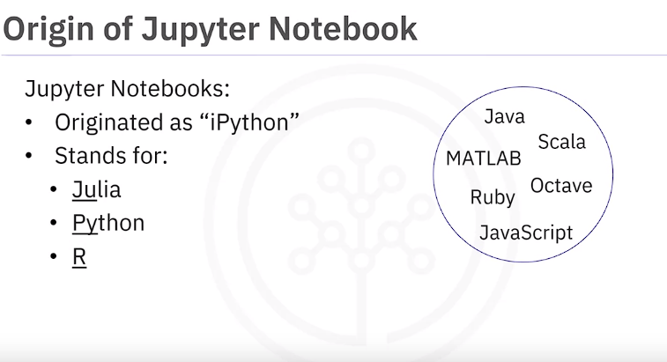

**Jupyter Kernel**

1. **Definition of Kernel**: A kernel in the context of Jupyter Notebooks refers to **a computational engine that executes the code contained within the notebook file**. It is responsible for interpreting and executing the code written in the notebook cells.
2. **Automatic Launch of Kernels**: When a Jupyter Notebook document is opened, the **associated kernel launches automatically in the background**. As the notebook is executed, the kernel processes the code cells, performs computations, and generates outputs such as **text, images, or plots.**
3. **Availability of Jupyter Kernels**: Jupyter supports kernels for various programming languages, enabling users to work with different languages within the same notebook environment. This versatility makes Jupyter suitable for a wide range of tasks in data science and scientific computing.
4. 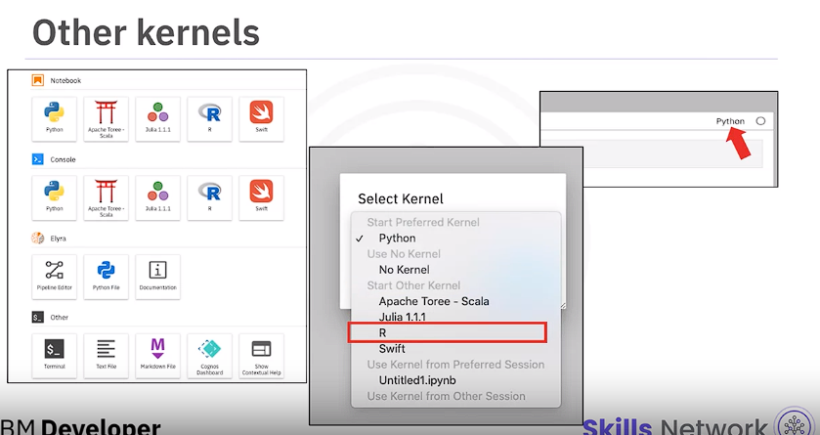
5. **Installation of Additional Kernels**: While some kernels may come pre-installed in certain environments, users may need to install additional kernels manually, especially if they require languages not included by default. This installation process typically involves using package managers or command-line tools to install the necessary components.
6. **Pre-installed Kernels**: In environments like the Skills Network lab, certain popular kernels such as the Python kernel may come pre-installed for convenience. This allows users to start working with these languages immediately without needing to set up additional configurations.
7. **Python Kernel**: The Python kernel is one of the most commonly used kernels in Jupyter Notebooks. It allows users to write and execute Python code directly within the notebook environment, making it a powerful tool for data analysis, visualization, and machine learning tasks.
8. **Kernel Selection**: In addition to Python, Jupyter supports a variety of other kernels, including Apache Spark, Julia, R, and Swift, among others. Users can select the desired kernel either during notebook creation or by changing the kernel from within an existing notebook.
9. **Manual Installation**: For users running Jupyter Notebooks on their local machines, installing additional kernels may require manual intervention. This typically involves using package managers like pip or conda to install the necessary kernel packages, along with any dependencies.
10. **Flexibility of Kernels**: Kernels serve as computational engines that execute code within Jupyter Notebooks. Their flexibility allows users to work with different programming languages and frameworks, depending on the requirements of their projects. This flexibility extends Jupyter's utility beyond Python-centric workflows, making it a versatile platform for data science and scientific computing.

In summary, understanding Jupyter kernels is essential for leveraging the full capabilities of the Jupyter Notebook environment, enabling users to work with multiple languages and frameworks seamlessly within a single interface.

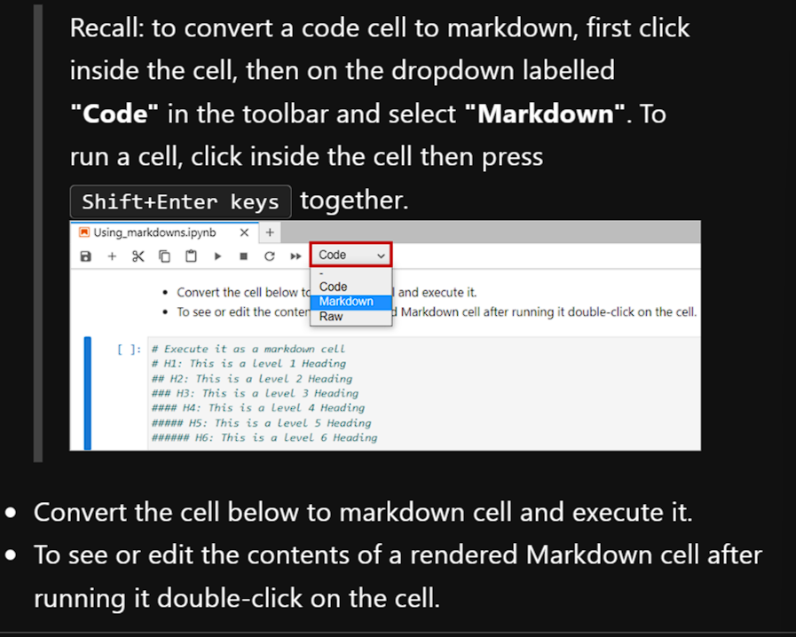Top of Form

**\*\*Bold Text using asterisks.\*\***

**__Bold Text using underscores.__**

**# Execute it as a markdown cell**

***Bold and Italic text using asterisks.***

___Bold and Italic text using underscores.___

# Execute it as a markdown cell

[Skills Network](<https://skills.network/>)

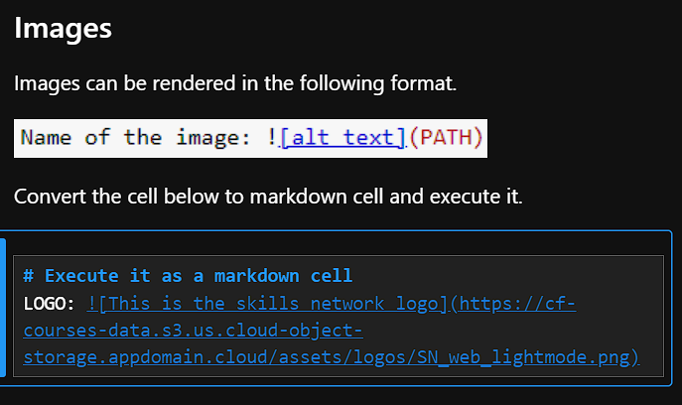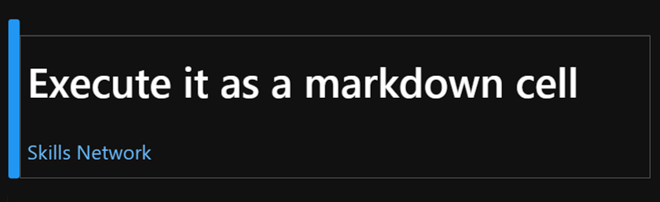

**Table Creation**

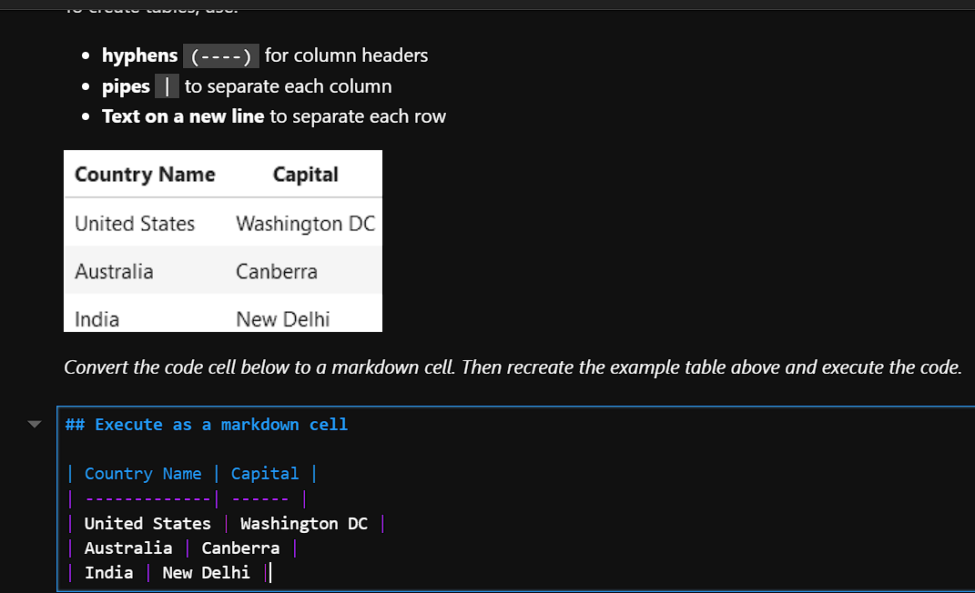

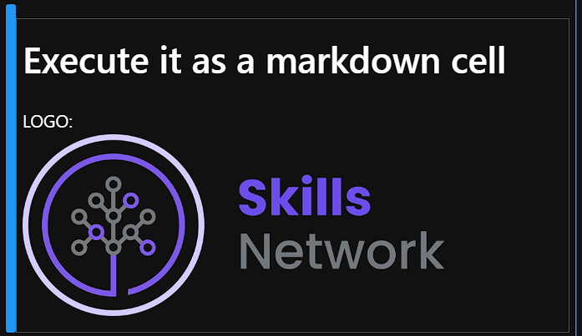

**Convert the code cell below to a markdown cell. Then recreate the unordered list displayed above using dashes (-), asterisks (*), and plus signs (+). Then execute the code.**

**# Execute as a markdown cell**

**- First item using dashes**

**- Second item using dashes**

**- Third item using dashes**

**- Fourth item using dashes**

**\* First item using asterisks**

**\* Second item using asterisks**

**\* Third item using asterisks**

**\* Fourth item using asterisks**

**+ First item using plus**

**+ Second item using plus**

**+ Third item using plus**

**+ Fourth item using plus**

**JUPYTER ARCHITECTURE**

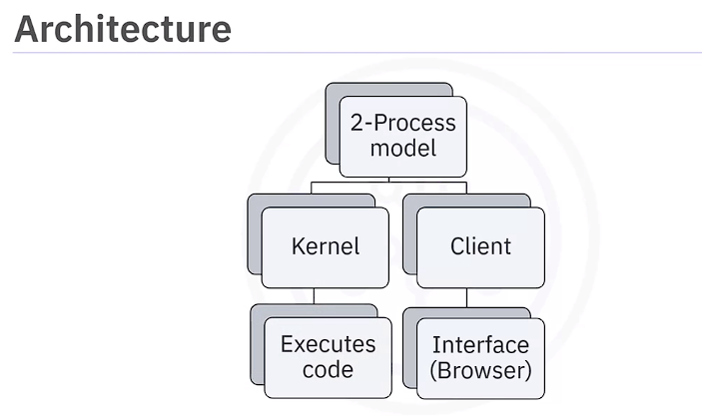

1. **Jupyter Architecture**: Jupyter architecture follows a two-process model comprising a kernel and a client**. The client, typically a *web browser in the case of* Jupyter Notebook, provides the interface for users to interact with the kernel by sending code for execution.**
2. **Role of Client and Kernel**: The client sends code to the kernel, which executes it and returns the results to the client for display. **The kernel is responsible for executing the cells of code contained within the notebook.**
3. **Notebook Structure and Saving: Jupyter Notebooks consist of code, metadata, contents, and outputs**. When a notebook is saved, it is sent from the browser to the **notebook server, which then saves it as a JSON file with a .ipynb extension on disk. The notebook server handles saving and loading of notebooks.**

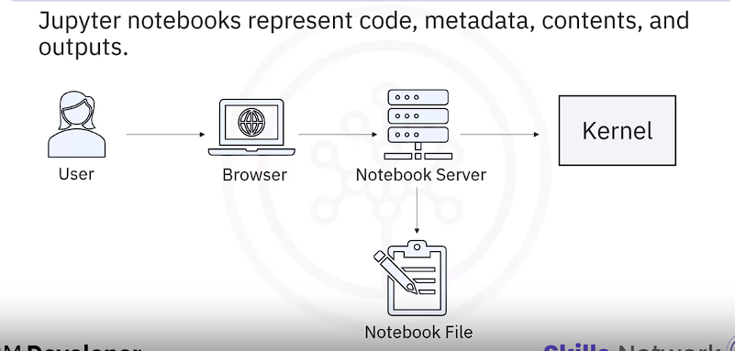

1. **Conversion of File Formats**: Jupyter architecture includes the use of the **NBConvert tool for converting notebook files to other formats**. For example, to convert a notebook to an HTML file, the notebook is first **modified by a preprocessor**, then exported to the desired format by **an exporter**. Finally, **a postprocessor may perform additional modifications on the exported file to produce the final output.**
2. **Displaying Converted Files**: After conversion, the converted file, such as an HTML file, can be accessed using its URL, and it will be displayed accordingly.
3. **Summary of Learnings**: In summary, the video teaches that Jupyter implements a two-process model with a kernel and a client, with the kernel responsible for executing code and the client providing the interface for interaction. The notebook server handles saving and loading of notebooks, and the NBConvert tool facilitates conversion of files to other formats.

Additional Anaconda Jupyter Environments

1. **Jupyter Notebooks and Computational Notebooks**: Computational notebooks combine **code, computational output, explanatory text, and multimedia resources into a single document.** Jupyter Notebook is a popular type of computational notebook that supports multiple programming languages.
2. **Anaconda Distribution**: Anaconda is a free and open-source distributor for Python and R, the top languages used in data science and machine learning. It comes with over fifteen hundred pre-installed libraries and is free to install with **community support available**.
3. **Anaconda Navigator**: Anaconda Navigator is a graphical user interface (GUI) that allows users to manage their Anaconda environment, including installing new packages **without using the command line interface (CLI).**

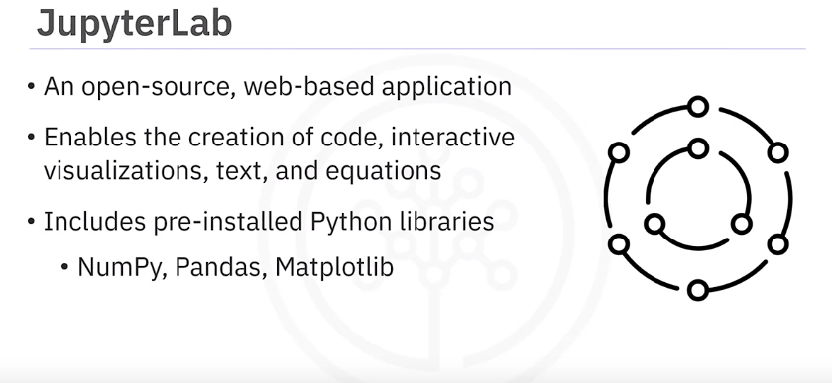

1. **Jupyter Environments in Anaconda Navigator**: Anaconda Navigator includes JupyterLab and Visual Studio Code (VS Code) as Jupyter environments. JupyterLab is a web-based application similar to Jupyter Notebook, while VS Code is a free, open-source code editor for debugging and task-running operations.
2. **Launching JupyterLab and Jupyter Notebook**: Users can launch JupyterLab from Anaconda Navigator by clicking the "Launch" button in the JupyterLab box. If the button is missing, users can click "Install" first and then "Launch". Similarly, users can start Jupyter Notebook by searching for it in the search bar of Anaconda Navigator.
3. **Creating and Managing Notebooks**: In JupyterLab, users can create a new Python 3 notebook by clicking "New" and selecting "Python 3". They can rename the notebook and work with different cell types, including Code and Markdown cells, to execute code or write rich text.
4. **Downloading Notebooks**: Users can download their notebooks by going to the "File" menu and selecting "Download as". They have several download options available.
5. **Using VS Code with Anaconda Navigator**: VS Code can be launched from Anaconda Navigator. Users need to install a few extensions to execute Python code in VS Code. Once installed, they can create a new Jupyter Notebook file, write code, and execute it within VS Code.
6. **Configuration of VS Code**: It's noted that a separate installation of VS Code outside of Anaconda Navigator will work similarly but may not be configured for Anaconda, Python, or Jupyter Notebooks by default.

In summary, the video introduces Anaconda and its data science features, explains how to use Anaconda Navigator to manage Jupyter environments, and demonstrates the process of creating, managing, and downloading notebooks in JupyterLab and VS Code.

Top of Form

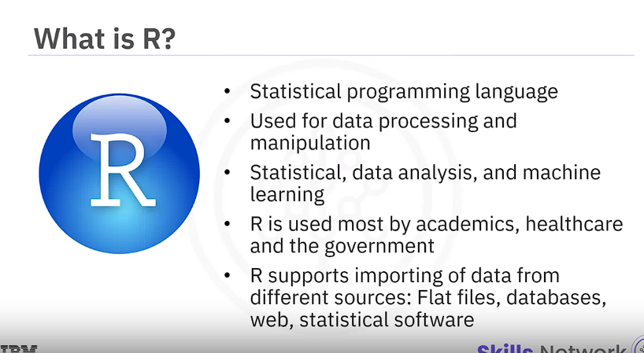

1. **What is R**: R is a statistical programming language known for its power in data processing and manipulation, statistical inference, data analysis, and machine learning algorithms.
2. **R Capabilities**: R is capable of importing data from various sources such as **flat files, databases, web, and statistical software like SPSS and STATA. I**t is preferred by academics, healthcare professionals, and government agencies.
3. **Ease of Use**: R functions are known for their ease of use, making it a preferred language for some data scientists. It also produces **great visualizations** and contains packages for data analysis **without the need for additional libraries**.
4. **RStudio Environment**: RStudio is a popular integrated development environment (IDE) for R programming. **It includes features such as a syntax-highlighting editor with direct code execution, a console for typing R commands, and tabs for workspace, history, files, plots, packages, and help.**

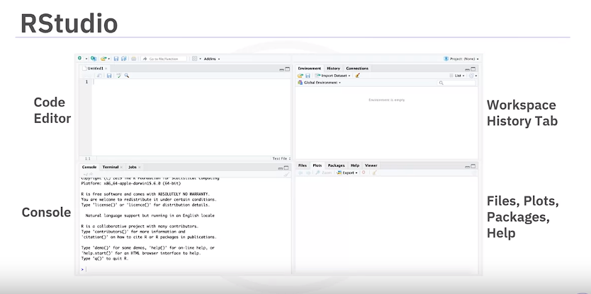

1. **R Libraries for Data Science**: Popular R libraries in the data science community include:
   * **dplyr**: For data manipulation.
   * **stringr**: For string manipulation.gggggggggggggg
   * **ggplot**: For data visualization.
   * **caret**: For machine learning.
2. **R Studio Virtual Environment**: As part of the Skills Network Labs, learners are provided with an R Studio virtual environment to practice what they learn without the need for creating an account or downloading and installing anything.

In summary, the video covers the capabilities of R in data science, introduces the RStudio environment for running R code, and highlights popular R packages used in data science applications.

Top of Form

**GIT AND GITHUB**

1. Git and GitHub are popular environments among developers and data scientists for performing version control of source code files and projects and collaborating with others.
2. A version control system allows you to keep track of changes to your documents, making it easy to recover older versions and collaborate with others.
3. Git is free and open source software distributed under the GNU General Public License, a distributed version control system.
4. Users anywhere in the world can have a copy of your project on their own computer with Git.
5. Git **repositories can be used without a web interface through the command line interface,** but GitHub is one of the most popular **web-hosted services for Git repositories**.
6. SSH (Secure Shell) protocol is a method for secure remote login from one computer to another. It is commonly used for securely accessing and interacting with Git repositories hosted on remote servers, such as those on GitHub, GitLab, or Bitbucket.
7. Basic terms include SSH protocol, repository, fork, pull request, and working directory.
8. 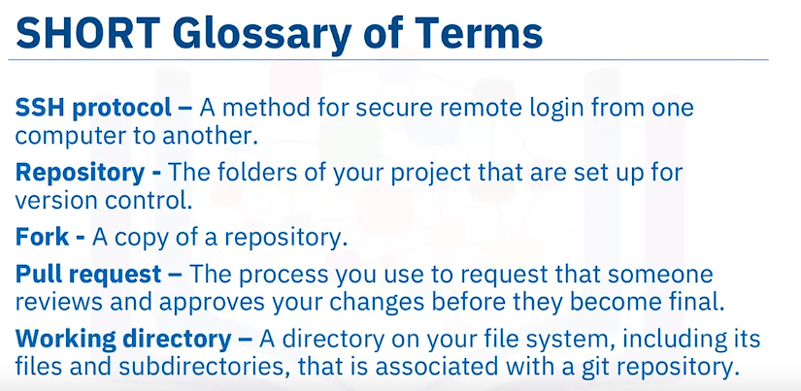
9. Basic Git commands include "git init", "git add", "git status", "git commit", "git reset", "git log", "git branch", "git checkout", and "git merge".
10. "git add" moves changes from **the working directory to the staging area**.
11. "git status" allows you to see the **state of your working directory and the staged snapshot of your changes.**
12. "git commit" takes your staged snapshot of changes **and commits them to the project**.
13. "git reset" **undoes changes made to files in your working directory**.
14. "git log" enables you to **browse previous changes to a project.**
15. "git branch" lets you create an **isolated environment within your repository to make changes**.
16. "git checkout" lets you **see and change existing branches.**

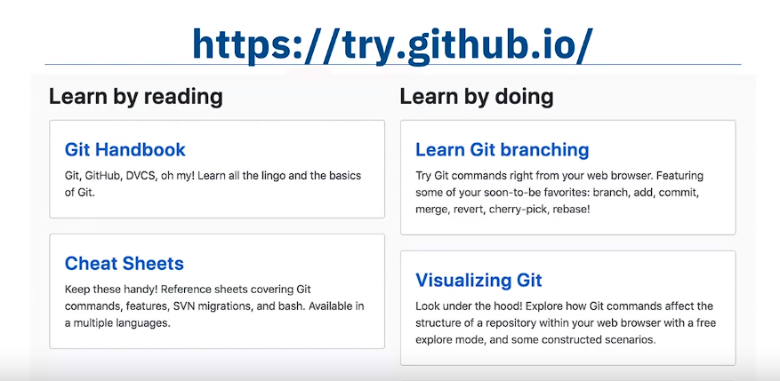

1. "git merge" lets you put everything back together again.
2. To learn how to use Git effectively, you can use resources available on GitHub such as cheat sheets and tutorials on try.github.io.
3. The following modules will provide a crash course on setting up your local environment and starting a project.
4. **BitKeeper and Linux Development**: BitKeeper was a version control system used for managing Linux development in the early 2000s. **It was initially free-to-use but transitioned to a for-fee system in 2005.** This change posed challenges for Linux developers, leading to the development of a replacement system.
5. **Development of Git**: created in 2005 by Linus Torvalds led the development of Git as a **replacement for** BitKeeper. This decision was prompted by the need for a new source-version control system that addressed the challenges faced by Linux developers after BitKeeper's transition to a **for-fee model.**
6. **Key Characteristics of Git**: Git was designed with specific characteristics in mind to meet the needs of developers. These include **strong support for non-linear development**, **distributed development allowing each developer to have a local copy of the full development history**,
7. It serves as a central point for collaboration with a particular focus on **agile development**

**methodologies.**

1. compatibility with existing systems and protocols, efficient handling of large projects, cryptographic authentication of history ensuring identical code updates across distributed systems, and pluggable merge strategies to handle complex integration decisions.
2. **Git as a Distributed Version-Control System**: Git is primarily focused on tracking source code during development. Unlike centralized version control systems, each developer in Git has a **complete copy of the repository's history on their local machine**. This distributed nature enables developers to work offline, collaborate asynchronously, and maintain their own development branches.
3. **Benefits of Distributed Development in Git**: With Git's distributed development model, each developer can work independently on their local copy of the repository. Changes can then be shared and synchronized between repositories, allowing for non-linear workflows and flexible collaboration patterns.
4. **Continuous Integration with Git**: Git facilitates continuous integration by allowing teams to continuously integrate changes that are ready for release into a main branch while simultaneously working on separate feature branches. This approach ensures that the main branch remains deployable at all times and reduces the risk associated with large-scale integrations.
5. **Centralized Administration and Access Controls**: Git provides centralized administration of tasks, allowing teams to manage access levels and permissions for each team member. This ensures that only authorized users can perform certain actions, such as merging changes into the main branch or creating new branches.
6. **GitHub as an Online Hosting Service: GitHub is an online hosting service for Git repositories,** offering **free, professional, and enterprise accounts.** It provides a centralized platform for hosting, collaborating on, and managing Git repositories, making it easier for developers to work together and share their code with others.
7. **GitHub's Popularity and Repository Count**: GitHub, hosted by a subsidiary of Microsoft, has become extremely popular, boasting over **100 million repositories as of August 2019**. Its widespread adoption is attributed to its user-friendly interface, powerful collaboration features, and integration with popular development tools.
8. **Definition of a Repository**: A repository is a data structure for storing documents, including **application source code, and enables contributors to track and maintain version control**. In the context of Git**, a repository contains all the files and folders associated with a project, along with metadata that tracks changes over time.**
9. **GitLab as a DevOps Platform: GitLab is a comprehensive DevOps platform that provides access to Git repositories and offers features for source code management, collaboration, testing, and delivery. It allows developers to collaborate on code, review each other's work, and streamline the software development lifecycle.**
10. **Features of GitLab**: GitLab enables developers to collaborate by reviewing code, making comments, and improving each other's code. It supports working from local copies of the code, branching and merging code when necessary, and streamlining testing and delivery through built-in Continuous Integration (CI) and Continuous Delivery (CD) capabilities.